 | BQ24210 Solar Charger  Instructions

Date: | 12/7/2023 | Version: | 1.1 | By: | Matt Little

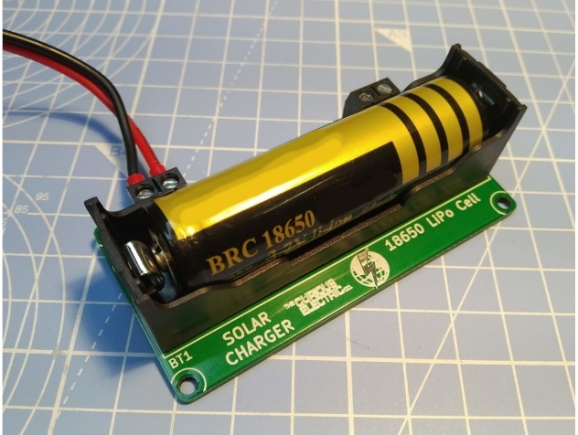  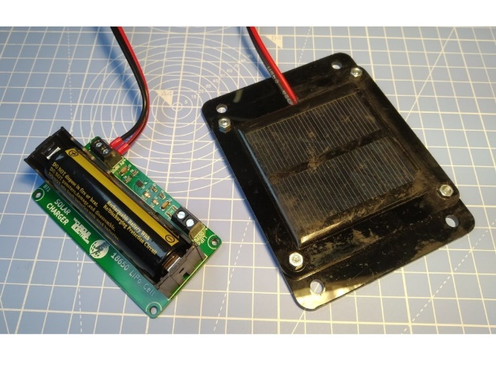 | This is a solar lithium-ion single cell battery charger unit using the Texas Instruments IC BQ24210.  It is designed to run small electronics projects (such as data-loggers and environmental monitoring units) in places where there is no supply of electricity. I designed it originally to run a small weather station which monitored and wirelessly sent back data to a base station.  This is a 800mA single-input, single cell Lithium Ion battery charger IC. The datasheet is available here: http://www.ti.com/lit/ds/slusa76b/slusa76b.pdf  This IC is pre-soldered, as it is a very small surface-mounted package, along with all the other main components.  You only need to solder the battery holder and screw terminals.  You need to add a small solar panel with an output voltage of (ideally) between 3.5 and 7V DC. I use modules with 5.5V output and 200mA.  Note: The 18650 lithium ion Cell is NOT supplied!  Note: The solar panel is NOT supplied!
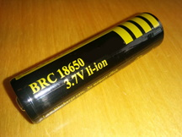
*Note: We do NOT supply the 18650 size lithium ion cell. This is due to shipping restrictions. These cells are usually available locally.
We suggest getting a good-quality cell with a decent capacity (in the region of 2000-3000mAh).

Parts included:
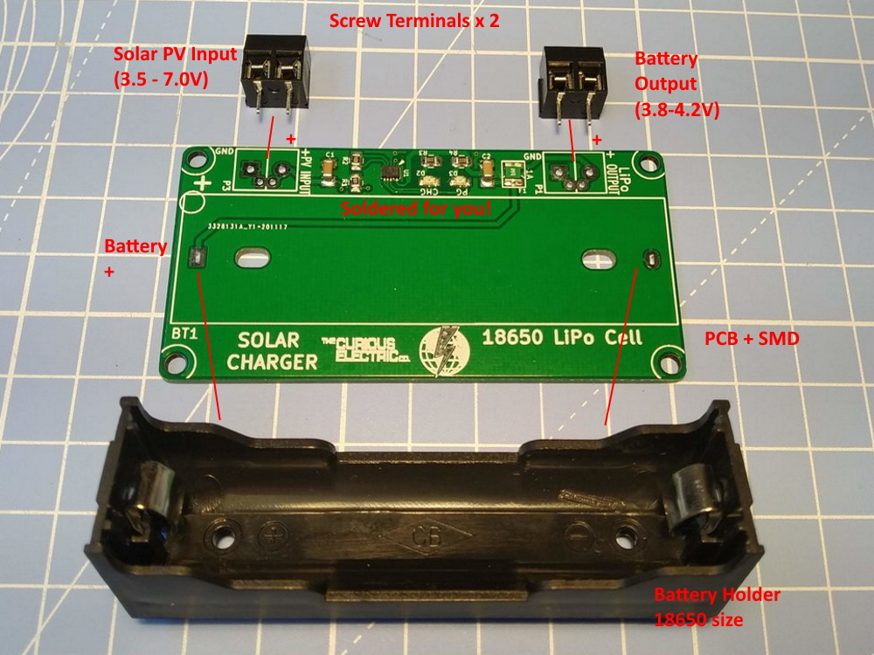

Kit Parts List:
Ref | Item | Quantity | Ref | Item | Quantity
BT1 | 18650 Cell Holder | 1 | PCB | PCB with soldered components | 1
P1, P3 | Screw Terminals | 2

Tools required:
 | 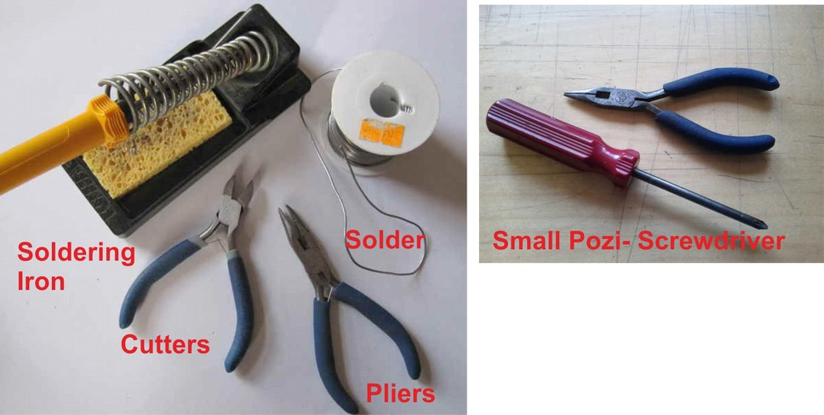
Long-nosed
Pliers
Soldering Iron |  | Posi-drive  Screwdriver
Solder
Side cutters

Instructions:
Step: 1 | Solder the components
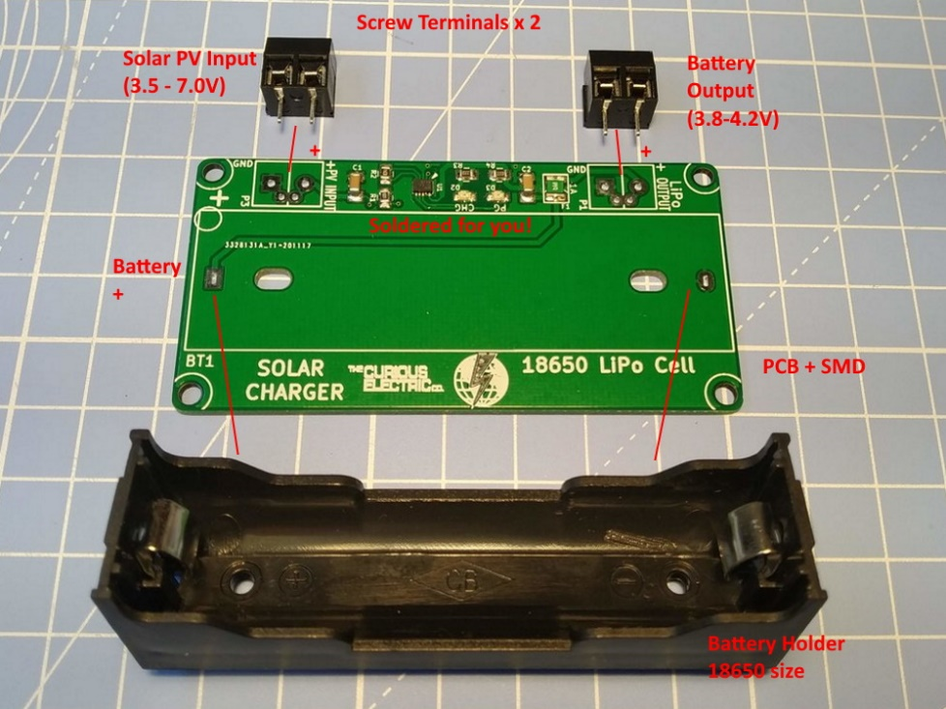 |  | Want to solder P1 and P3 with the terminals facing out away from the PCB.  There are holes to add a JST type connector (but socket not supplied).  Place the battery holder in the component marked BT1.  Check that the +ve terminal aligns with the + on the silk screen of the PCB.

Step: 2 | Add an 18650 lithium-ion Cell
Double check the polarity! |  | 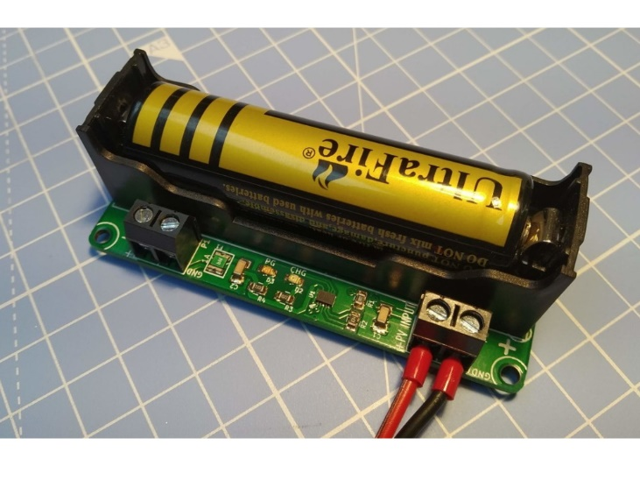

Step: 3 | Add a solar PV module
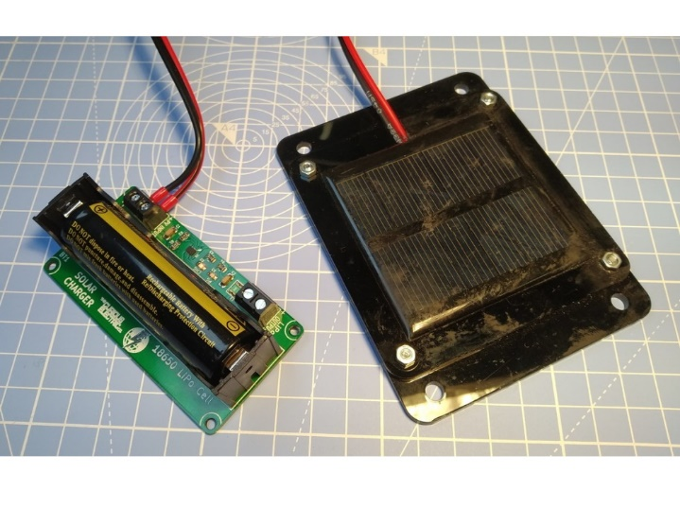 |  | Add a small solar panel wired to the solar input.  You can power your circuit from the power output terminal. This is protected by a 500 mA resetting fuse (with trip current of 1A).

Testing & Operation
You will need a small solar panel, with an output voltage of between 3.5-7V DC. The max solar PV voltage is 18V DC. The max current output is set to 400mA, so a solar panel with an output of around 400mA is most suitable. I use a 5.5V panel with 200mA output and it works well.

Initially the battery may be totally discharged.
Place the unit in the sun for a while. The red LEDs D1 and D2 should light after a while. This may take 5-10mins in weak sunlight.

- The PG LED shows that there is enough sunlight to power the IC.
- The CHG LED shows that the battery is charging.

A 5000mAh battery will take around 14 hours of strong sunlight to fully charge the battery. This would be around 4 days in the summer and around 14 days (!) in winter (in the UK!) to fully charge the battery from empty.

The output power is direct from the lithium cell, in which case this will be a variable voltage between around 3.7V to 4.2V. This is protected by a 500mA / 1A trip resetting fuse.

This unit is designed as a building block for your projects. It has many uses - from powering data-logging systems to emergency recharging of mobile devices.

Note: The weather and available sunlight is variable, so there are no definite rules about recharging times. If outside on an average UK summers day the batteries will be fully charged in around 3-4 days. If outside on an average UK winters day then the batteries will be fully charged in 10-15 days. If used behind a window, the glass will affect the available sunlight and increase the recharge times by a factor of at least 50%.

The circuit diagram shows the components. Some notes from the data sheet include:
- Ts is pulled high (with 100k) for solar charging applications
Limited current mode to ensure battery temperature OK
- VDPM is kept open for load tracking, such as solar PV
- The max current setpoint (Iset) is set by R1
2W of solar PV gives 400mA maximum
Riset = Kiset/Iout Iout = 400mA. Kiset = 395Aohm. Riset = 987.5. (1k used)
- EN tied to PG as load mode never used

Full design files for the PCB and these instructions and datasheets are available in the github repository for this project here:

https://github.com/curiouselectric/solar_charger_2020

Contact details:
This kit has been designed and produced by:
The Curious Electric Company
hello@curiouselectric.co.uk
www.curiouselectric.co.uk

We would like you to be happy with this kit. If you are not happy for any reason, then please contact us and we will help to sort it out.

Please email hello@curiouselectric.co.uk with any questions or comments.
Please tweet us at @curiouselectric

If any parts are missing from your kit then please email hello@curiouselectric.co.uk with details, including when and where the kit was purchased.

More technical information can be found via www.curiouselectric.co.uk

Circuit Schematic:

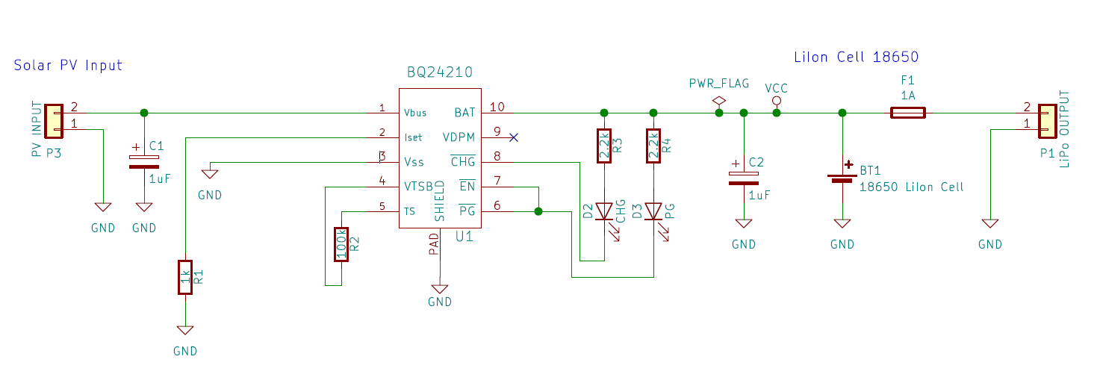

PCB
